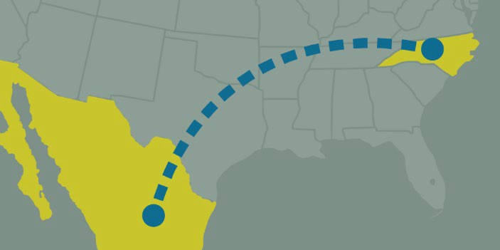

Heritage and Migration in North Carolina

New Latin American Studies course!
LTAM 390 and 690, Spring 2020 APPLES service learning

Experience and document North Carolina’s Mexican and Latin American history. This three- credit course combines field research, oral history, and service learning to understand the immigration and settlement of North Carolinians with Mexican and Latin American heritage. The course will address the ethical and practical aspects of the ethnographic method including the preparation, transaction and transcription of oral history interviews. Students will participate in the New Roots Nuevas Raíces initiative and spend spring break completing field research and public service in a community in North Carolina. Students will also complete an independent research project and public presentation.
The course is open to advanced undergraduates and graduate students (Undergraduate students will enroll in LTAM 390; graduate students will enroll in LTAM 690). Required: 3 semesters of Spanish or ability to demonstrate Spanish language proficiency. Recommended: previous courses in Latin American or Latina/o/x studies, qualitative methods, or migration studies.
Travel expenses, including lodging, transportation, and food, are provided for students. Students are required to apply for this course. The deadline for application is October 14, 2019. To apply, email instructor Hannah Gill, hgill@email.unc.edu requesting an application. Please note that applications will require a letter of recommendation.

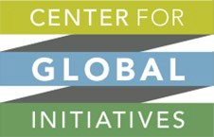
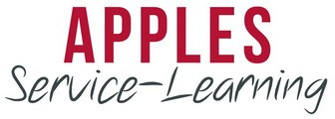
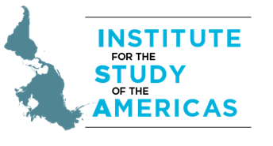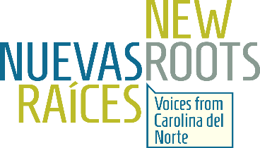

Heritage and Migration in North Carolina Application
LTAM 390 and 690, Spring 2020
Deadline: October 14, 2019

Please type information

I. Personal Information

Name: | Major (if applicable):
Email Address: | Year:  * Open to sophomores, juniors and seniors, and graduate students with Spanish language proficiency
Phone Number: | PID #:
Permanent Address:

Essay questions: (Please type your answers on a separate page, maximum 1500 word total)

- Why are you interested in this course? What do you hope to gain as well as contribute?

- Please relate any reflections or knowledge gained from prior public service experiences.

- Please describe any leadership experiences or insights gained from working with/in a group or team. How might this translate into being part of a team of UNC students spending spring break in a North Carolina community?

- Have you taken any qualitative methods courses? If so, please describe.

- Describe an experience in an unfamiliar or new setting. How did you handle the challenges or opportunities of this experience?

Statement of Understanding
I understand that I must be proficient in Spanish [equivalent to 3-4 semesters of college Spanish]. **Interviews will be conducted partially in Spanish**
I understand that as an APPLES Service Learning Course, the spring break experience is alcohol-free for everyone. We are committed to having a responsible, respectful presence in the communities we serve.
I understand that I will be required to attend a mandatory orientation in December. Date TBA

Please submit the following with your completed application:
One letter of reference from a former teacher or employer who can attest to your leadership, character, and academic performance, submitted in a sealed envelope with a signature across the back seal, or by email from the reference to hgill@email.unc.edu. Please include a phone number for the reference. Please submit letters to Hannah Gill, 3205 Fed Ex Global Education Center, CB 3205, 301 Pittsboro Street, Chapel Hill, NC 27599-3205
A current resume

How to submit:
The application materials should be emailed to hgill@email.unc.edu by 5pm on October 14, 2019.

