Latin American Studies Major Katie Kenlan’s Study Abroad Experience in Argentina

Katie Kenlan is a junior majoring in Latin American Studies. Katie was attracted to the LTAM major as it allowed her to design her own studies and strengthen her well-rounded education across different departments such as Anthropology, Political Science and African, African American, and Diaspora Studies. As a transfer student, she was also able to connect her previous studies to the LTAM major. Katie shared that “the LTAM degree helped her gain critical thinking skills, study important historical, cultural and sociological areas that influence our current society and other global communities.” Additionally, she enjoys the direct support from the department.

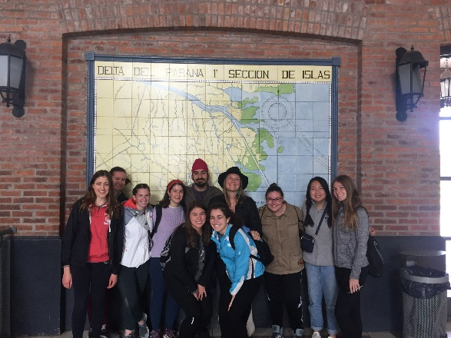
This semester Katie is studying abroad in Argentina. While searching for a study abroad program, she wanted to find a big city with lots of art and cultural opportunities. She was drawn to Argentina because it was a mix of European and Latin American cultures and the ability to travel within one of the largest countries in the world. At school, she has been learning about the different towns and regions outside the city of Buenos Aires. Argentina is very geologically diverse with mountains, plains and coastal regions. She plans to visit Bariloche, Jujuy and Salta. Since she’s been living in Argentina, Katie has fallen in love with the beautiful Castellano accent. She is pleased to report that her Spanish proficiency has really advanced. As a food lover, she has been exploring multiple restaurants and cafes. She’s learned more about the Argentine economy and its colonial legacy since the exchange rate greatly favors American dollars and Western currencies. Additionally, she has the opportunity to directly relate to politics as the country is about to vote for a new president.

When Katie returns to UNC in fall 2020, she wants to write a senior
thesis and apply to graduate school to study psychology. Now that she feels much more confident about her Spanish, she looks forward to taking more Spanish classes. She is ready to move to another city and navigate big challenges ahead.

